Introduction:
Our survey is about fake news, and this survey is about spreading awareness about fake news and seeing other people’s perspectives and understanding of fake news. Many people had different responses and opinions. We are doing this survey for grades 9 and 10, because fake news is a complicated topic. We got 60 responses to our survey.
Q1. 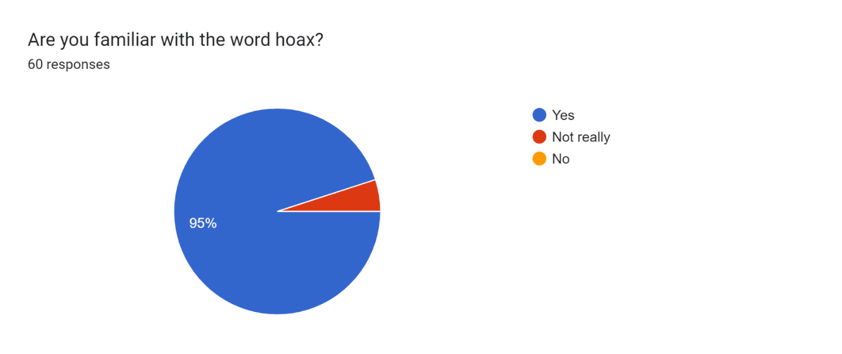
The graph above shows that most people in grades 9 and 10 are familiar with the word hoax. Only a little bit of them are not really familiar with the word hoax, but no one is completely unfamiliar with it. A lot of people seem to be a little bit aware of fake news, and they are quite familiar with it.
Q2. 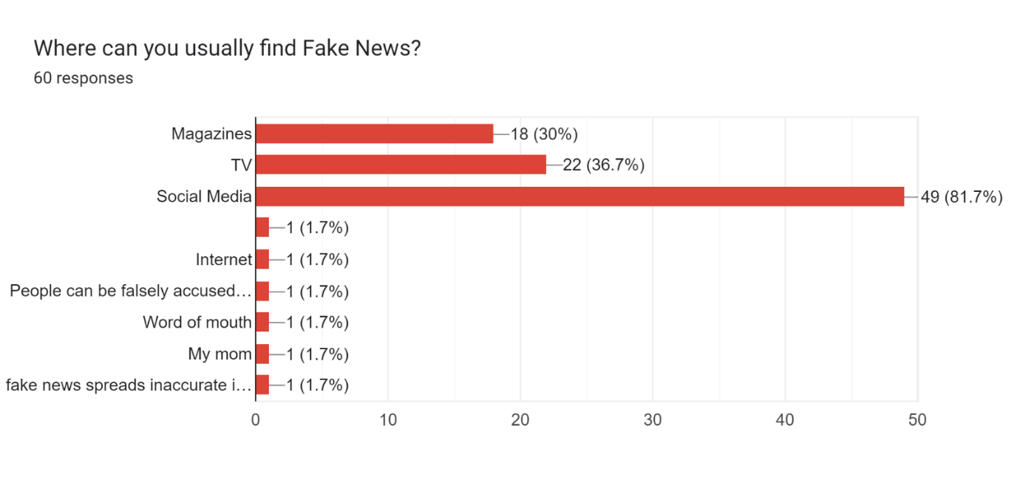
This graph shows that most people find fake news in social media, TV, and magazines, but they rarely find it on the internet and word of mouth. 18 people find it on magazines, 22 on TV, and 49 on social media.
Q3. 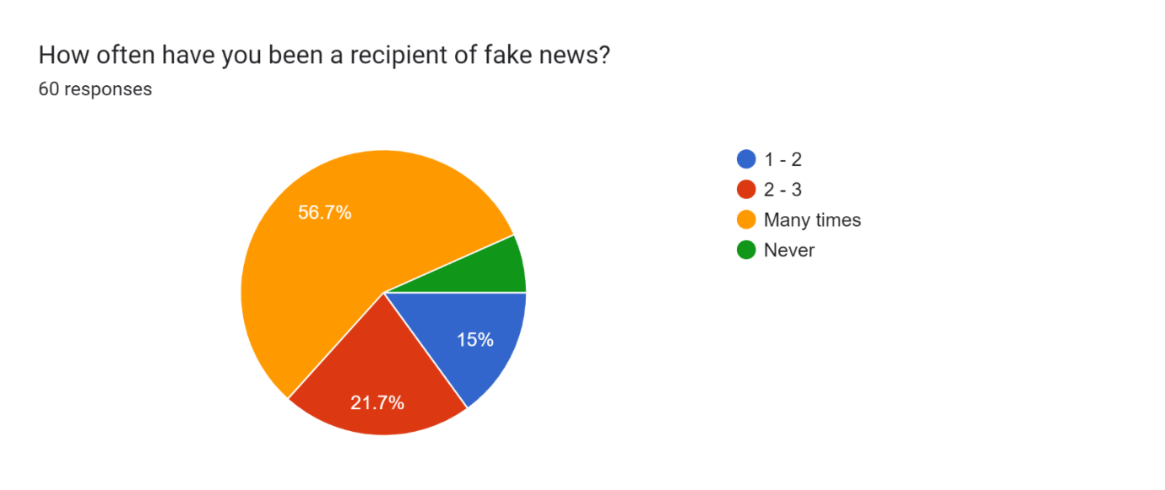
34 people have experienced fake news many times, and 4 people have never experienced it. Some people have experienced it 1 – 3 times, so fake news seems really common in their grades. A lot of people seem to be familiar with fake news, and most have experienced it many times.
Q4. 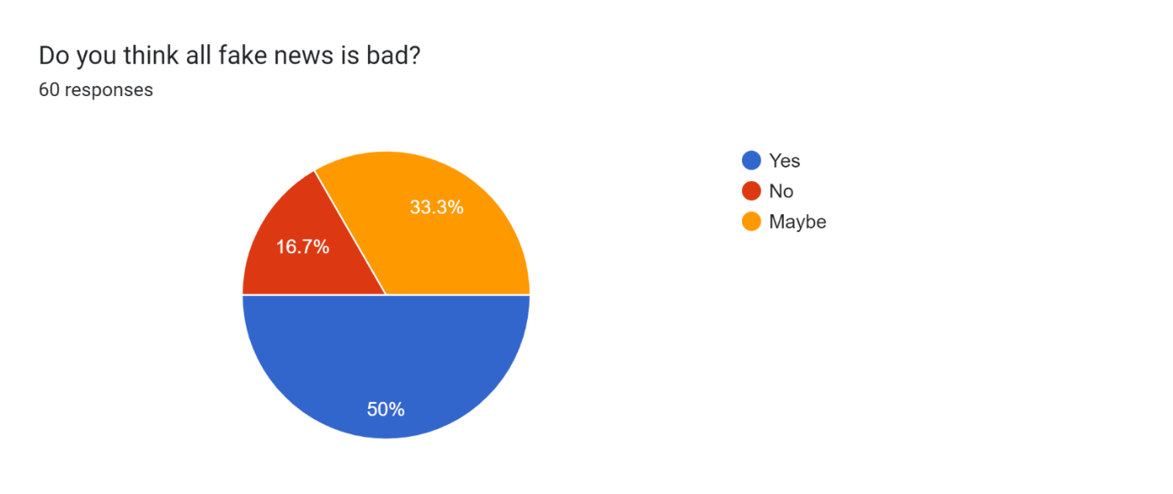
Most people said that fake news is bad, while 20 people said maybe, and 10 people said no. 30 people think that all fake news is bad, probably because they have experienced it, while some people might think that fake news is not all bad and might have some positive impacts.
Q5. 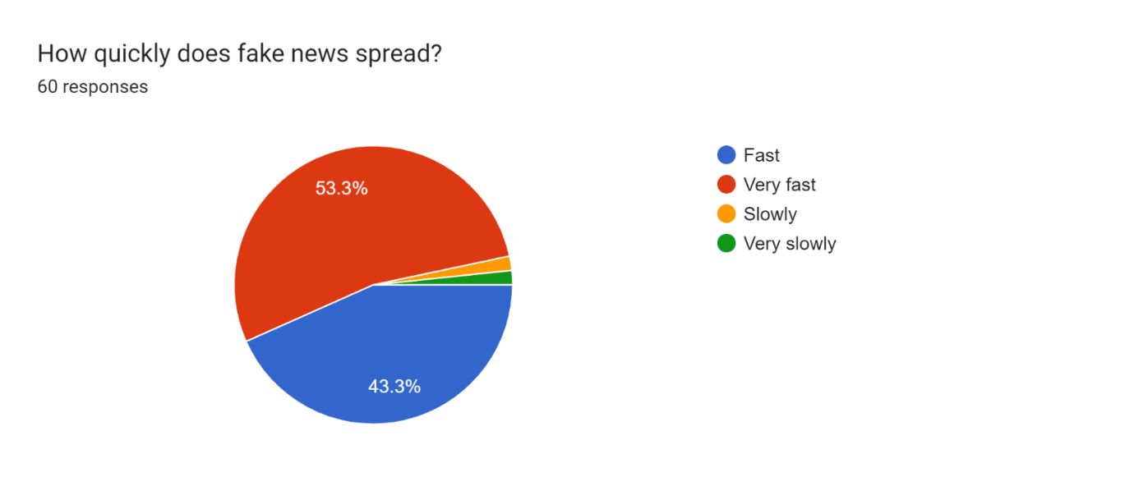
32 people think that fake news spreads very fast, and 1 person said it spread very slowly. People might think differently of how fast fake news spreads depending on how popular it is. Fake news can spread faster if there are more people sharing it.
Q6. 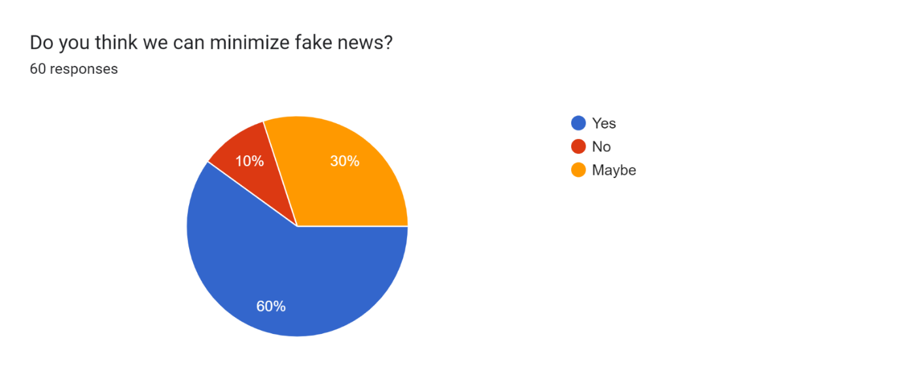
36 people think that we can minimize fake news, while 6 people said we can’t. 18 people said we might be able to, depending on the action. People might think differently of how we can minimize fake news, because of how complicated it is.
Q7. 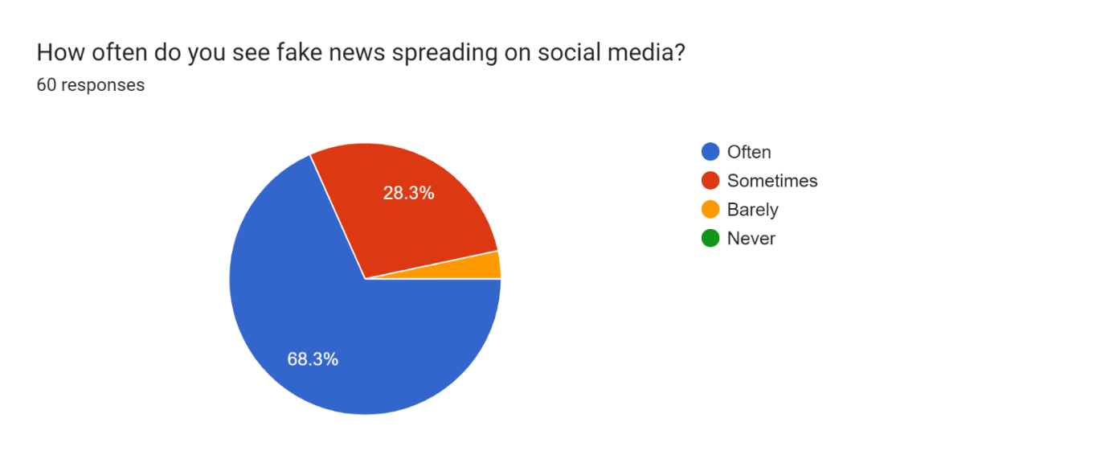
41 said that they see fake news spreading on social media often, while none said never, 17 said sometimes, and 2 said barely. This is probably because a lot of people are trying to spread fake news for money, fame, or to advertise.
Q8. 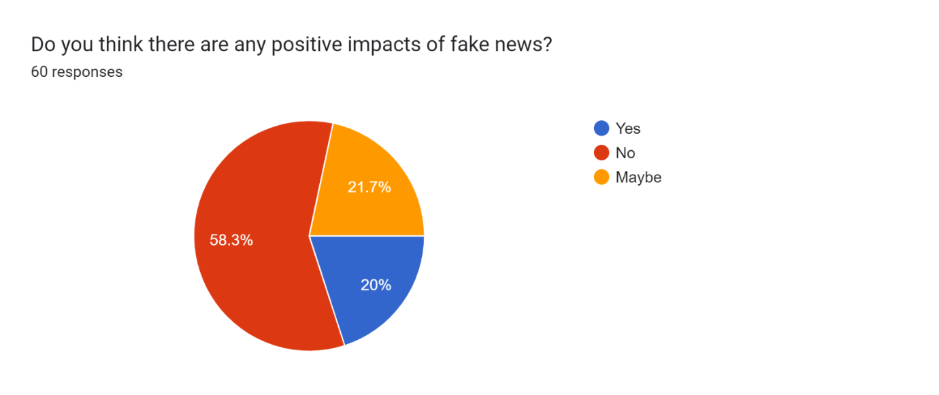
35 people said there are no positive impacts of fake news, while 12 said yes and 13 said maybe. Some people might think that there are quite a lot of positive impacts, and some think there are none. This is probably because they might have experienced fake news that seemed to make a positive impact.
Q9. If yes, please explain.
We got 17 responses. People said things like you can make people to follow you, and another person said By using fake news, you can utilize it to your advantage by changing the attention from the "real" news to the "fake" news. People also said that fake news could be to hide some private information, and to spread awareness about other issues. Someone also said that it could help the public gradually understand it and not fall for it again, and someone else said people could be falsely accused of things and that fake news could also be satire.
Q10. 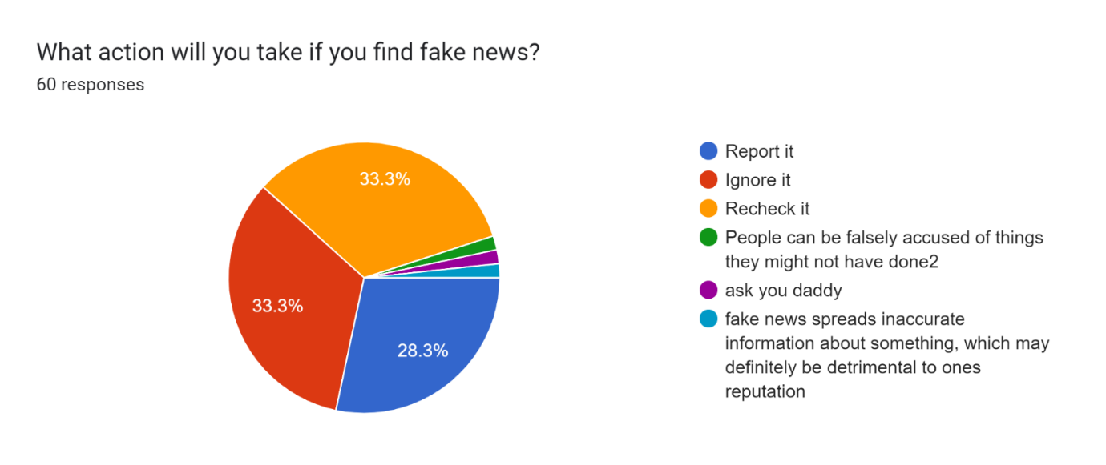
Based on the graph, 20 people would recheck it, 20 people would ignore it, 17 people would report it. Very little people said other things, probably because they might know a different way to act.
Q11. 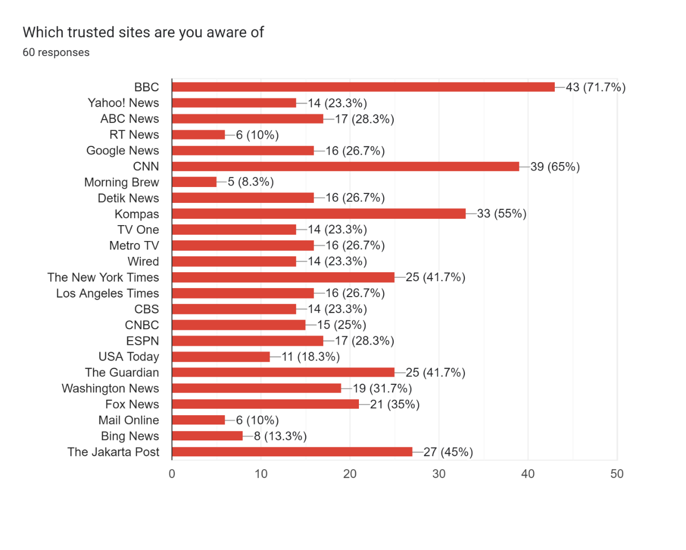
Based on the graph, most people are familiar with BBC, Google News, and Kompas, and very little people are familiar with Morning Brew, RT News and Mail Online. This is probably because they are more familiar with the more popular sites.

